**LINDALE & NEWTON-IN-CARTMEL PARISH COUNCIL**

## ANNUAL PARISH MEETING

**Notice of Meeting of Parish Council of AGM/APM**

**in Lindale Village Hall at 7.00 pm on Wednesday 15th May 2024**

**Guest Speaker**

**Lucy Earl, Assurance Coordinator –**

**North West Ambulance Service NHS Trust**

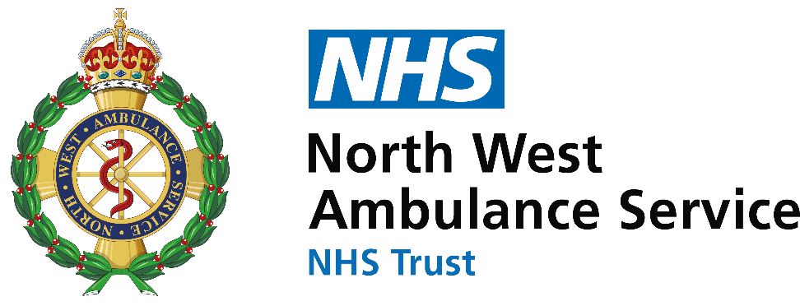

## 

1. **Introduction and Welcome by Chair 2023/24 - Cllr Ian Maynard**
2. **Chair’s Annual Report of Parish Council activities for 2023/24.**

**3 Introduction of Guest Speaker –Lucy Earl, Assurance Coordinator – North West Ambulance Service NHS Trust. Lucy will talk about recruitment of more volunteers’ car drivers for Cumbria to support our Patient Transport with the 1.2 million journeys per year.**

1. **Q & A - Parish Councillors and Westmorland and Furness Councillor**
2. **After presentation members of the public will be invited to raise questions.**

***Following the AGM, refreshments will be served, we hope you will be able to join us.***

**Next meeting Wednesday 19th June 2024 in Lindale Village Hall at 7.00 pm**